Last updated on 20 April 2006
Changes:
- All points on the four curves taken into account (in the first version first points on each curve where ignored). This changes the “last correct points” found by the procedure.
- Weighted fit done taking into account the correlation between deflection shifts errors.

Author: Natalia Emelianenko

Case of 2273 at ITP20-GEO

The magnet 2273 was measured twice (19-Jan-2006 and then 31-Jan-2006 after the pressure test, same operator is recorded for both measurements) since the first measurement had very large distance between curves measured from different sides:

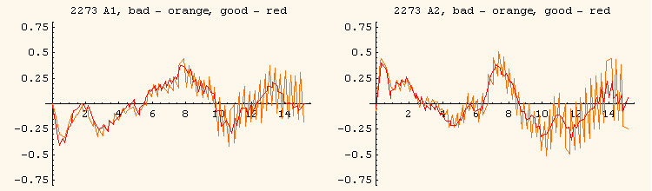

The best fit (simple average) for the GA “places” the good measurement almost in the middle between the two bad curves, so that one can conclude that there was no need to redo the measurement:

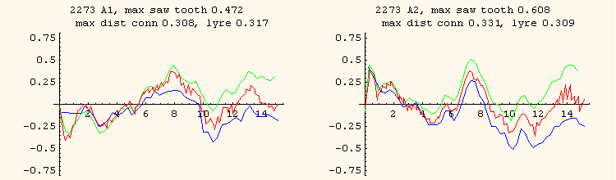

In the picture above the max saw tooth height (distance L∞ between green connection and blue lyre curves) and max distance (L∞) from “bad” connection to “good” connection curves (idem for lyre curves) are given in mm.

How the saw tooth can be explained in this case? Since the two curves coincide near the connection side, it could mean that near the connection side there were some special air conditions making the laser beam deviating from the straight line.

One temperature test performed at firm 2 (16.03.2006 at 11:30) shows that the difference between the temperatures of the ambient air near the opposite dipole extremities was 1.18 ºC and the temperature gradient inside the tube at the lyre side was ΔT ≈ 2ºC over 2m and twice less at the connection side. The temperature in the middle of the tube was constant:

One can suppose that for the first measurement of 2273 the picture was a “mirror” of this one (temperature gradient was present at the connection side).

If we apply the correction procedure to the bad measurement we get the following results. The distances to “last good points” from flanges minimizing the saw tooth for each aperture are:

Last good point at the connection side, aperture 1: | 0.8 m
Last good point at the lyre side, aperture 1: | 1.0 m
Last good point at the connection side, aperture 2: | 1.2 m
Last good point at the lyre side, aperture 2: | 1.6 m

The reference line construction for each aperture is shown on the figure below:

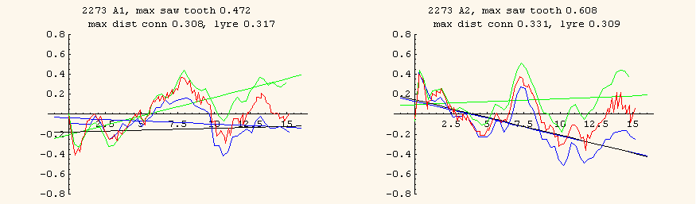

The curves translated on the reference line have the saw tooth reduced to 0.12 and 0.13 for the apertures 1 and 2:

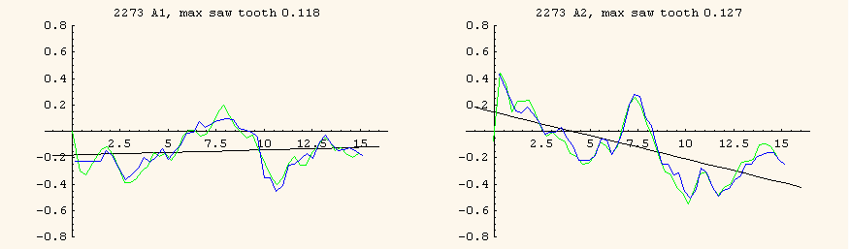

This perfect match gives us the possibility to treat the shifts used for the translation as the “errors due to the light deflection” (the difference between curves is very close to linear):

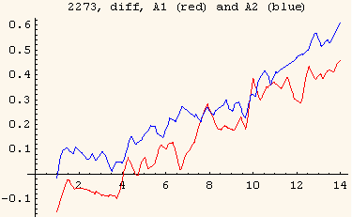

We make a weighted fit taking into account the mole error (0.07mm), the error of the bundle adjustment (0.08mm), laser tracker error (5ppm) and the “deflection shift” by minimizing the expression:

$$χ^{2}={\left(z−z_{e}\right)}^{Τ}⋅(u^{2})^{−1}⋅\left(z−z_{e}\right)$$

Where z is the vector of all dZ of all four curves, z_{e} is the expected values of the model function (z_{e}= a y + b), u² is the error covariance matrix for dZ. Its diagonal elements are the errors at each point i:

$u_{i,i}^{2}={\text{errorBundle}}^{2}+{\text{errorMole}}^{2}+{\text{errorLaser}}^{2}+{\text{deflectionShift}}^{2}$

The diagonal elements of the inverted error covariance matrix (weights = 1/u_{i,i}²) is shown below:

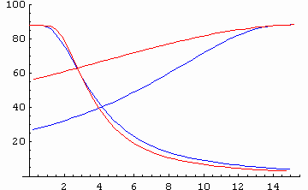

Non diagonal elements of u² are:

$$u_{i,j}^{2}=\text{cov}(h_{i},h_{j})=\text{correl}(h_{i},h_{j})⋅h_{i}⋅h_{j}=h_{i}⋅h_{j}$$

Here h_{i} and h_{j} are the deflection shifts at points i and j, if they belong to the curves (connection and lyre) of the same aperture, and

$$u_{i,j}^{2}=0$$

if they belong to different apertures (results for 2 apertures are not correlated). Correlation between deflection shifts for the points of one aperture is assumed to be 100%.

We get the following GA (green line is the result of the weighted fit, and orange line is the result of the correction procedure – weighted fit of the translated curves with only laser tracker error taken into account):

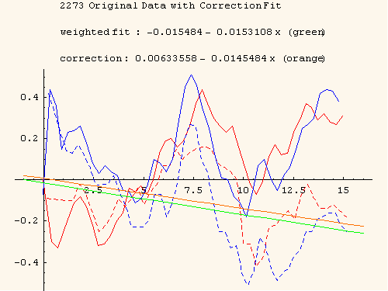

In the new reference system based on the corrected GA the original curves look as follows (connection side beam is deflected down due to the temperature gradient, so the points were seen higher than their real positions):

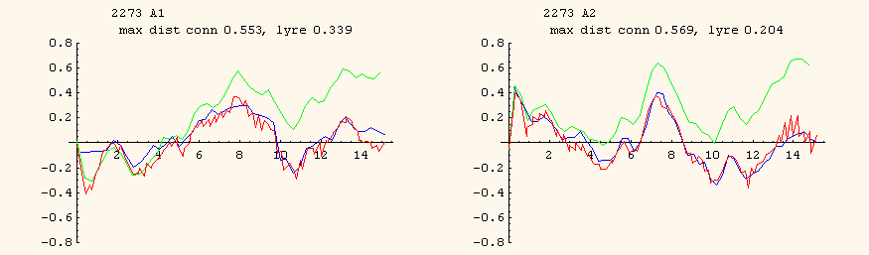

To see the match of the translated curves with the good measurement we plot them in the new reference system (the max distance is improved from 0.3 to 0.2 mm):

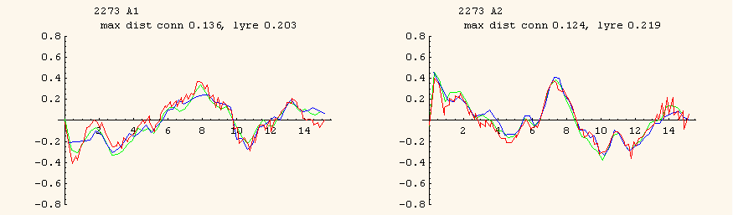

We should not expect the perfect match since the shape of the magnet could have changed between the two measurements due to the cold feet pad positions change:

May be, the change of the cold feet pads positions with respect to the GA is not “real” but induced by wrong (simple average) GA calculation. As we see from the correction fit the GA must be rotated clock-wise around the connection extremity, which is consistent with the cold feet pad height change.

Furthermore, if we check the flanges positions we see that they also had changed with respect to GA (which was supposed to stay on the same place) as if both apertures were rotated clock wise:

Match with the weighted fit on the translated curves

If we make the weighted fit (laser tracker error) on the translated curves, the result is equivalent to that of the weighted fit with “deflection shifts” errors. Below there is a plot of the GA shift and slope obtained by the weighted fit on the translated curves (red point inside the blue ellipse (confidence intervals)) and the GA shift and slope obtained by the weighted fit with “deflection shifts” (green point).

