Beam Deflection in a Tube
Natalia Emelianenko

Problem
In a long tube, having inside it a temperature different from that of the outside and well isolated from the ambient temperature along it, there must be convection areas near the tube extremities (see [1] [2]). The temperature map of such area in YZ plane is shown below (the picture is taken from [2]).
Figure 1. Temperature Map at the Cold BoreTube Extremity
The temperature gradients cause the beam deflection in the vertical plane and the only remedy seems to be the evacuation of the air from the tube [3]. Another remedy is to create a constant laminar gas flow in a tube, and this seems to be not applicable since the reflector sits on a mole which may block the tube as a piston.
The analysis of the saw tooth pattern in the dipole measurements shows that the two curves measured from different sides of the tube are “rotated” one with respect to another and the difference between them is very close to linear. On the Figure 2 the measurement which difference is one of the most deviating from a straight line is shown.
In most cases for the CERN tests at WP08 (where the dipole might still be cold inside after the cold test) the curves rise from the side where the measurement was started. Now we will try to explain this behaviour with a very simple calculation.

Figure 2. Dipole 3428 A1, WP08-FID.

The right plot shows the two curves measured from the connection and from the lyre side, the left plot shows the difference between connection and lyre curves calculated using the linear interpolation. The Y coordinate is laid out on the abscissa; the ordinate is the dZ value. Y is given in meters, dZ in mm.

Calculations
The width of the convection area is about 200mm and it starts around 150mm from the tube extremity [2].

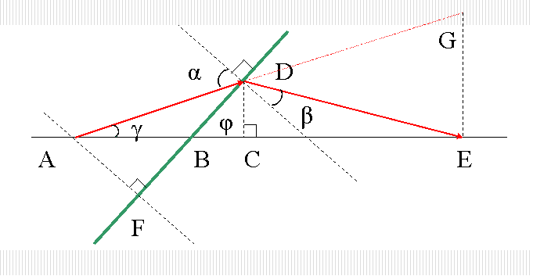
Figure 3. Beam refraction in the tube. YZ plane. Red line is the light beam, green line - the isoterm.
On the Figure 3 the connection side of a cold bore tube is drawn. Let the point A be the laser tracker eye and the point E the reflector. The plane DF separates the air with different temperatures and represents the thin refraction zone. The cold air is to the right of the plane DF (inside the tube). Since the cold air has higher refractive index, the beam changes the direction after passing the plane DF. Therefore, to “find” the point E the laser beam must follow the line ADE.

The angles α and β obey the Snel's law:
1
$$n_{1}\text{sin}α=n_{2}\text{sin}β$$

This can be extended to a second layer (see the Figure 1), and then to a third. The product ((n_{i} /n₀) sin α_{i}) at every interface remains equal to the sine of the initial incidence angle. All layers thus work as a single one.

Let φ be the angle between DF and AE and γ is the hunting angle of the tracker. If the point E is found by the laser, its visible position – point G – is higher than the real position of E. Let us calculate the distance GE:

$$α=π/2−(ϕ−γ)$$
2
$\left|\text{GE}\right|=\text{tan}γ⋅\left(\left|\text{AB}\right|+\left|\text{BC}\right|+\left|\text{CE}\right|\right)=\text{tan}γ⋅\left(\left|\text{AB}\right|+\frac{\left|\text{CD}\right|}{\text{tan}ϕ}+\frac{\left|\text{CD}\right|}{\text{tan}(π/2−ϕ−β)}\right)$ ,

where $\left|\text{CD}\right|=\left|\text{AB}\right|⋅\frac{\text{sin}γ⋅\text{sin}ϕ}{\text{cos}(π/2−(ϕ−γ))}=\left|\text{AB}\right|⋅\frac{\text{sin}γ⋅\text{sin}ϕ}{\text{sin}(ϕ−γ)}$

Since the retro-reflector is always found by the laser tracker and the measured deviation from a straight line does not exceed 1mm, the angle γ must be less than
3
$γ≤\text{arctan}\left(\frac{0\text{.}\text{001}}{\text{15}}\right)≈{\text{10}}^{−4}$

The condition $0<\left|\text{CE}\right|<∞$ together with the equations 1 and 3 limits the possible angles γ and φ.
4
$$β=\text{arcsin}\left(\frac{n_{1}}{n_{2}}⋅\text{sin}α\right)=\text{arcsin}\left(\frac{n_{1}}{n_{2}}⋅\text{sin}(π/2−ϕ+γ)\right)$$
5
$\frac{n_{1}}{n_{2}}⋅\text{cos}(ϕ−γ)<\text{cos}ϕ$

The ratio $\frac{n_{2}}{n_{1}}$ is defined by the difference of the air temperature. We will use the simple formula for refractive index of air given in the NIST documentation [4].
Here, p is pressure in kPa, t is temperature in Celsius, and RH is relative humidity in percent (that is, ranging from 0 to 100). They say that “This formula is only valid for the standard, red He-Ne laser wavelength of approximately 633 nm…. The equation is expected to be accurate within an estimated expanded uncertainty of 1.5×10⁻⁷ (0.15 ppm) for temperatures between 0 °C and 35 °C, pressures 50 kPa to 120 kPa, humidity 0 % to 100 %, and CO₂ concentration between 300 µmol/mol and 600 µmol/mol.”
We assume that all these conditions are met and take the pressure 100kPa and humidity 80%. To get the maximum temperature range let the temperature of the warm air be 35˚, and we get for the different temperatures of the cold air:
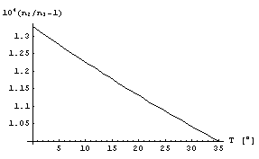
Figure 4. Air refractive index ratio with respect to the air of 35˚ at 100 kPa

Having now the air refractive index, we will try to find the angles which meet the condition$0<\left|\text{CE}\right|<∞$.
Figure 5. The max hunting angle γ of a tracker for different temperatures of the cold air and for different angles of the isoterm φ (left plot φ range is 0 to 0.3, light plot – 0 to 0.01). shows the limit surface when the parts of the inequality 5 become equal. It is a 3D plot for
Solve[Cos[φ]==Cos[φ-γ],γ]
for different ranges of φ. We see that for small γ the isotherm angle φ cannot be small (if the reflector is finally found by the laser tracker), and the lower bound for φ depends on the temperature.
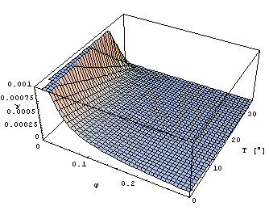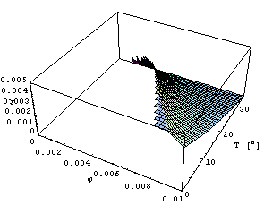
Figure 5. The max hunting angle γ of a tracker for different temperatures of the cold air and for different angles of the isoterm φ (left plot φ range is 0 to 0.3, light plot – 0 to 0.01).
The Figure 6 shows at which angles φ we can have the positive value for the distance |CE| for very small γ. This is simply the plot of the function
tan(π/2 – φ – β).
The angle β is calculated from the φ and γ and the refractive indices using the formula 4.

Show[
Plot3D[Cot[/2--newAlpha[T, /2-+]],{,0.000000001,0.0001}, {,0.0000001,1}, PlotPoints50,MeshFalse, AxesLabel{"", "", ""}],
Plot3D[0,{ ,0.000000001,0.0001},{,0.00000001,1},PlotPoints20],
ViewPoint{3, -2.4, 2}]
See the definition of newAlpha below (Figure 7)

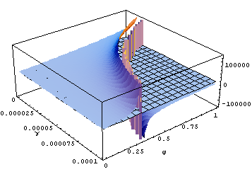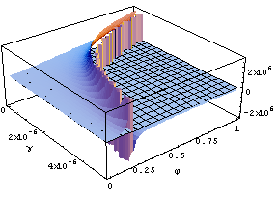
ΔT=35˚
ΔT=1˚
Figure 6. Possible solutions for the angles for ΔT = 35˚ and for ΔT = 1˚, the solution surface intercepts the plane z=0 to make visible the zones with positive CE distance.

Now, having found that the ranges for the angles seem to be reasonable (small hunting angle and isotherm angle around π/4 for ΔT=35˚), we can try to estimate how the deviation depends on the distance to the reflector.

Let us put d = |AB|, l = |BC|, L = |CE|, h = |CD| and H = |GE|, and let ψ be the angle DEC.

$$H=\left(d+l+L\right)⋅\text{tan}γ$$

Since h = o(d) and ψ is very small:

$$\text{tan}γ=\frac{h}{d+l}=\frac{h}{d+h⋅\text{cot}ϕ}≈\frac{h}{d}=\frac{L⋅\text{tan}ψ}{d}≈\frac{L}{d}⋅ψ=\frac{L}{d}⋅\left(\frac{π}{2}−\left(ϕ+β\right)\right)$$

Let β = α + r, where r is obviously very small. From the equation 1 we get:

$$n_{1}⋅\text{sin}α=n_{2}⋅\text{sin}\left(α−r\right)=n_{2}⋅\left(\text{sin}α⋅\text{cos}r−\text{cos}α⋅\text{sin}r\right)≈n_{2}⋅\text{sin}α−r⋅\text{cos}α$$
$$β=α−\left(1−\frac{n_{1}}{n_{2}}\right)⋅\text{tan}α=\frac{π}{2}−ϕ+γ−\left(1−\frac{n_{1}}{n_{2}}\right)⋅\text{cot}(ϕ−γ)$$
$$\text{cot}(ϕ−γ)≈\text{cot}ϕ+\frac{γ}{{\text{sin}}^{2}ϕ}$$
$$\text{tan}γ=\frac{L}{d}⋅\left(\frac{π}{2}−ϕ−\frac{π}{2}+ϕ−γ+\left(1−\frac{n_{1}}{n_{2}}\right)⋅\left(\text{cot}ϕ+\frac{γ}{{\text{sin}}^{2}ϕ}\right)\right)≈γ⇒\text{tan}γ≈\left(1−\frac{n_{1}}{n_{2}}\right)⋅\frac{L\text{cot}ϕ}{L+d}$$

So
$$H=(d+l+L)⋅\left(1−\frac{n_{1}}{n}\right)⋅\frac{L\text{cot}ϕ}{d+L}≈L⋅\left(1−\frac{n_{1}}{n}\right)\text{cot}ϕ$$
6

Thus, H is linear function of L, and the slope depends on the temperature difference and the angle φ.

A simulation was made in Mathematica with the exact functions. It also shows that the deviation H is a linear function of the distance d + l + L.

We put angle φ = π / 4, d = |AB| = 0.5 m and get the exact match with the approximated formula and with the real measurements results (note: the temperature inside the tube is unknown for the real measurements).

n[x_]:=SetPrecision[1+0.0786/(273+x) - 1.5 10^(-11) 80/(x^2+160),20];
newAlpha[T_, _]:=ArcSin[(n[35]/n[T])Sin[]];
hSmall[d_,_,_]:=d ((Sin[]Sin[])/Sin[-]);
dist[d_,_,T_, _]:=hSmall[d, , ](Cot[]+Cot[/2--newAlpha[T, /2-+]]);
height[d_,_,T_,_]:=(d + dist[d, ,T, ])Tan[];

d=0.5;T=5;
ParametricPlot[{dist[d, /4,T, ],height[d, /4,T, ]},{ ,0.000001,0.0001},
AxesLabel{"Distance [m]","Height [m]"}]

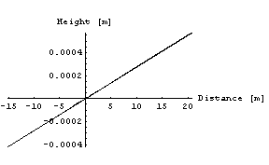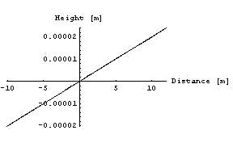
Figure 7. Simulation result for ΔT = 20˚ (left plot) and for ΔT = 1˚ (right plot)

References
- E. Ainardi, L.Bottura, and N.Smirnov, “Light beam deflection through a 10m long dipole model”, CERN LHC-MTA, Tech. Rep. May 1999.
- N. Smirnov et al. “The methods of the LHC Magnets’ Magnetic Axis Location Measurement”. IWAA 1999.
- P.Schnizer et al. “Experience from measuring the LHC Quadrupole axes”. IWAA 2004.
- NIST, Precision Engineering Division, Engineering Metrology Toolbox http://emtoolbox.nist.gov/Main/Main.asp, Refractive Index of Air Calculator http://emtoolbox.nist.gov/Wavelength/Abstract.asp

