For each point at each curve (measured from the connection or from the lyre side) we calculate the distance from the point linearly interpolated at same Y between the previous and the next points (red segment on the picture below):

This is the code used to build the statistics for all distances:

create table X_COMPLETE_AXIS
as
select distinct meas_id
from CRYOGEO_AXIS
where final_meas = 'T'
group by meas_id, aperture
having count(case when side = 'connection' then side
else null end) > 19
and count(case when side = 'lyre' then side else null end) > 19;

create table X_AXIS_LAG_LEAD as
select A.magnet_nu, A.step, A.meas_id, meas_date, A.aperture, A.side, A.point_id, Y, DX, DZ,
lag(y, 1, null) over (partition by A.meas_id, A.aperture, A.side order by y) prev_y,
lag(dx, 1, null) over (partition by A.meas_id, A.aperture, A.side order by y) prev_dx,
lag(dz, 1, null) over (partition by A.meas_id, A.aperture, A.side order by y) prev_dz,
lead(y, 1, null) over (partition by A.meas_id, A.aperture, A.side order by y) next_y,
lead(dx, 1, null) over (partition by A.meas_id, A.aperture, A.side order by y) next_dx,
lead(dz, 1, null) over (partition by A.meas_id, A.aperture, A.side order by y) next_dz
FROM CRYOGEO_AXIS A, CRYOGEO_MEAS_ENV B
where A.meas_id = B.meas_id
and side in ('connection','lyre')
and exists (select 1 from X_COMPLETE_AXIS where meas_id = B.meas_id)
order by MEAS_ID, APERTURE, SIDE, Y;

create table X_AXIS_Y_DIST
as
select MAGNET_NU, STEP, MEAS_ID, MEAS_DATE, aperture, side, point_id,
Y, DX, DZ,
DX - pda_utl.interpolateL2D(PREV_Y, PREV_DX, NEXT_Y, NEXT_DX, Y) diff_dx,
DZ - pda_utl.interpolateL2D(PREV_Y, PREV_DZ, NEXT_Y, NEXT_DZ, Y) diff_dz
from X_AXIS_LAG_LEAD
where PREV_Y is not null
and PREV_DX is not null
and PREV_DZ is not null
and NEXT_Y is not null
and NEXT_DX is not null
and NEXT_DZ is not null;

For all measurements (470013 points in total for 3610 measurements) we have the following statistics:

Average distance - 0.0007 mm
Standard deviation - 0.0716 mm
Min - -1.9548 mm
Max - 1.5542 mm

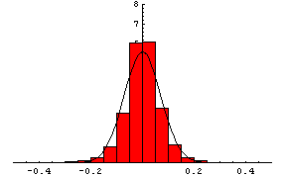

The distribution seems to be close to normal.

Also, most of the big distances are near the tube extremities and cannot be treated as the outliers. The chart below shows the average and the standard deviation of the “smoothness distance” over each 20 cm of the tube, all measurements:

The picture below shows all distances for all last measurements at WP08 for all magnets passed WP09 (ready to be installed in the tunnel).

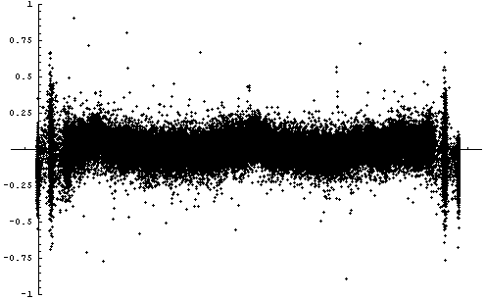

So the zone with stable distance can be chosen between Y = 1.4m and Y = 13.8m.

The statistics for this zone is the following:

All measurements:  Average = 0.0021mm,  standard deviation = 0.0639 mm | Last WP08:  average = 0.0037mm,  standard deviation = 0.0714 mm
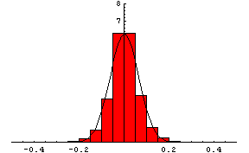 | 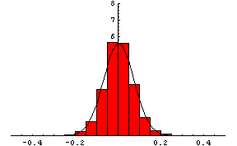

The following query was used to search for the outliers (6σ (0.024% over all points measured) from the mean in the central part of the tube):

select distinct magnet_nu, step, aperture, side
from X_AXIS_Y_DIST A
where y between 1.4 and 13.8
and abs(1000*diff_dz – 0.0021) > 6*0.0639
and (
(step like 'WP08%' and not exists (
select 1 from cryogeo_meas_env
where magnet_nu = A.magnet_nu
and step like 'WP08%' and step > A.step)
)
or step like 'ITP%')

This query gives 60 measurements which are suspicious for the outliers:

Magnet | Step | Aperture | Side
1068 | WP08C-FID | 2 | lyre
1080 | WP08C-FID | 1 | connection
1083 | WP08B-FID | 1 | connection
1088 | WP08B-FID | 2 | lyre
1176 | WP08B-FID | 1 | lyre
1181 | WP08-FID | 2 | lyre
1233 | WP08-FID | 1 | connection
1268 | WP08-FID | 2 | lyre
1271 | WP08-FID | 2 | lyre
1283 | WP08-FID | 1 | connection
1287 | WP08-FID | 2 | lyre
2007 | WP08C-FID | 1 | lyre
2012 | ITP20-GEO | 2 | lyre
2012 | WP08C-FID | 1 | connection
2014 | WP08E-FID | 1 | connection
2014 | WP08E-FID | 1 | lyre
2051 | ITP15-BCA | 2 | lyre
2059 | ITP15 | 1 | connection
2059 | ITP15 | 1 | lyre
2059 | ITP15-BCA | 1 | connection
2059 | ITP20-GEO | 1 | connection
2061 | ITP15 | 2 | connection
2061 | ITP15-BCA | 2 | connection
2086 | WP08B-FID | 2 | lyre
2104 | WP08C-FID | 2 | connection
2108 | ITP15 | 2 | lyre
2108 | ITP15-BCA | 2 | lyre
2109 | ITP15 | 1 | lyre
2109 | ITP15-BCA | 1 | lyre
Magnet | Step | Aperture | Side
2113 | WP08B-FID | 1 | connection
2129 | WP08-FID | 2 | connection
2129 | WP08-FID | 2 | lyre
2131 | ITP15 | 2 | lyre
2131 | ITP15-BCA | 2 | lyre
2133 | WP08B-FID | 2 | lyre
2147 | WP08-FID | 2 | connection
2162 | WP08-FID | 2 | connection
2163 | WP08-FID | 2 | lyre
2166 | WP08-FID | 2 | lyre
2179 | WP08-FID | 2 | lyre
2184 | WP08-FID | 2 | lyre
2195 | ITP15 | 2 | connection
2195 | ITP15-BCA | 2 | connection
2203 | WP08-FID | 1 | connection
2204 | WP08-FID | 2 | lyre
2208 | WP08-FID | 1 | connection
2259 | WP08-FID | 2 | lyre
2525 | WP08-FID | 2 | connection
3015 | WP08C-FID | 1 | connection
3173 | WP08B-FID | 2 | lyre
3241 | WP08B-FID | 2 | lyre
3244 | WP08D-FID | 2 | lyre
3263 | WP08-FID | 2 | lyre
3348 | WP08B-FID | 1 | connection
3386 | WP08-FID | 2 | connection
3395 | WP08B-FID | 1 | connection
3412 | WP08-FID | 1 | connection
3413 | WP08-FID | 2 | lyre
3415 | WP08-FID | 2 | lyre
3416 | WP08-FID | 2 | lyre

Each case should be investigated. A few examples:

Figure 1. Magnet 1283, Ap1.

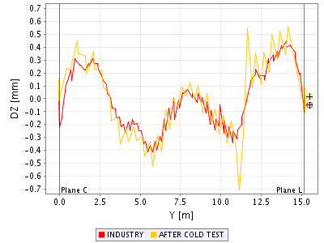

Figure 2. Magnet 2525, Ap2.
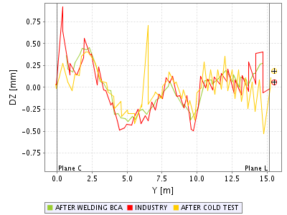

Figure 3. Magnet 2133, Ap2.

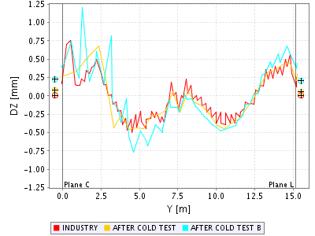

Figure 4. Magnet 3412, Ap1.

