Test of the Correction Procedure on the Linear Case
Natalia Emelianenko

Model
Let us take pure geometric problem: one aperture and two straight lines rotated over the points 0.5 m from the connection and lyre sides. Connection line (green) has the positive slope 0.01, lyre line (blue) – the negative slope 0.005. The “real” GA matches the Y axis.

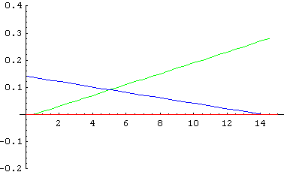
We sample 30 points from each line, one point every 0.5m, lyre points are shifted by 0.1m in positive direction. With merged points the “measurement result” looks as follows (red line is the “real” shape):

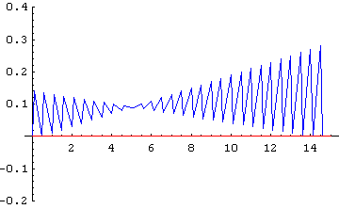

Now we suppose each point is measured with the following errors:

- All random errors not depending on Y — E_{M}
- Laser tracker error (depends on the distance from the laser) E_{L}
- Unknown beam deflection E_{B}

We will apply the correction procedure to these artificial curves.

Geometric Correction
Simple geometric correction would give the ideal match of the corrected and “real” GA. But the algorithm of the correction procedure using the linear fits of the curves cannot place the reference line exactly on the Y-axis and, as a result, the coefficients a and b of the corrected GA z = ay + b do not vanish.
E_{M} = 0.07mm (mole positioning), E_{L} = 5 ppm = 0.005 mm/m, weighting - $1/{E_{L}}^{2}$

1. First, we do not search for the “last correct point” but use the value 0.5m.
First version of the procedure (1st step: non-weighted fit of both connection and lyre curves to find the reference line, 2nd step: non-weighted fit of plied curves):

z = 0.000740406 -0.0000117215 y

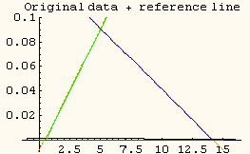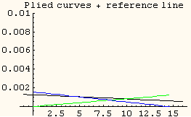
Figure 1. Reference line for simple fit

Weighted fit on the second step only (i.e. weighted fit of plied curves, the reference line is the same as in the previous example) gives the best result:

z = 0.000100735 + 4.58414 10⁻⁶ y

Weighted fit on both steps should give the worst result because the fits of the original curves (orange dashed line on the left plot below) are shifted by the weighting to the extremities and therefore the reference line is higher than y axis (black solid line):

z = 0.000747983 + 0.000028568 y

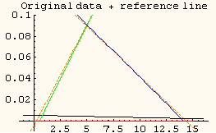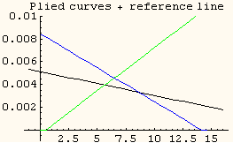
Figure 2. Reference line for the weighted fit
2. Now what will happen if we try to search for the last correct points? Let us first make non-weighted fit of the original curves. For the maximum distance between the plied curves we get (the number of steps from the connection and from the lyre side are laid down on X and Y axes):

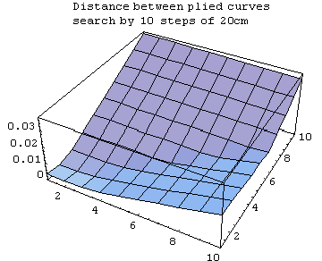
The minimum will be not 0.5m but:

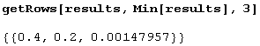

Another try (more steps, shorter steps, starting from 10 cm) gives the same result:

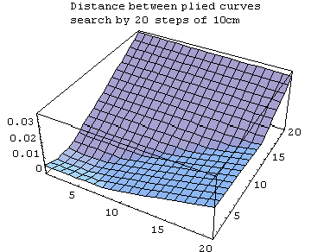

The reference line with these distances (0.4m from the connection side and 0.2m from the lyre side) happens to be below the Y axis:

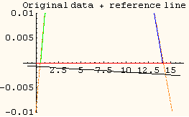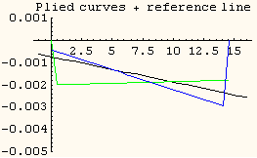

For the corrected GA with these “last correct points” we have:

z = - 0.00118907 - 0.0000748143 y (non weighted fit on step 2)
z = - 0.00106877 - 0.0000535636 y (weighted fit on step 2)

3. If we search for the “last correct points” making the weighted fit on the step 1 we get 10 times larger minimum of the distance between the plied curves:

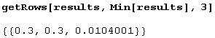

The reference line will be above the Y axis:

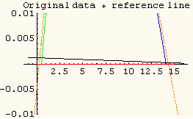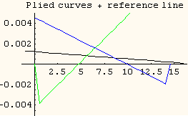

The corrected GA:

z = 0.000337541 + 0.000207292 y (non weighted fit on step 2)
z = - 0.00136734 + 0.0000704573 y (weighted fit on step 2)

Thus, we see that the success of the geometric correction of the GA depends on the selection of the “last correct points” and the choice of the weighting function on both steps and, therefore, if a weighting function ≠ 1 is used, on the correct estimation of the errors.

Weighted Fit
We use the geometric correction procedure to estimate the uncertainties caused by the light deflection. The criterion of the validity of such estimation is the quality of the match between the curves after plying them on the reference line.

Smallest distance between plied curves is obtained when using the non-weighted fit on the first step for the points 0.4m and 0.2m (max distance = 0.00148 mm). For 0.5m the max distance = 0.00152 mm.

We assume that the deflection shifts for the connection and for the lyre sides are not correlated. Only deflection shifts for points of one curve are correlated between each other and the correlation coefficient is 1. For the best “last correct points” 0.4m and 0.2m we get the following result:

z = 0.00395084 - 0.000106072 y

The shift and the slope are more important than for the geometrical correction made with the same “last correct points” (-0.00106877 - 0.0000535636 y).

Now, we check the Birge ratio (square root from χ² divided by the number of degrees of freedom) to assess the consistency of the model with the data:

Bi = 0.179975 < 1

This means that the uncertainty matrix is somewhat larger than reasonable, which is evident in our case. If we decrease the errors E_{M} and E_{L} we get the GA closer to the Y axis and by a few iterations we find that for E_{M} = 0 and E_{L} = 0.281ppm:

Bi = 0.999784 ≈ 1

The GA of the weighted fit: z = -0.00094991 - 0.0000483808 y
The GA of the correction: z = -0.00106877 - 0.0000535636 y

Taking “last correct points” distance 0.5m gives some strange results for the weighted fit. The first result (“big” errors) is z = 0.0056 - 0.000061 y, then decreasing the errors we soon get the coefficients very close to zero, slope ~10⁻⁹, shift ~10⁻⁸, but the Birge ratio does not grow and remains less than 0.19.

Confidence Intervals for the GA Coefficients
In case of “invalid” uncertainties (when the Birge ratio is < 0.2) the GA obtained by both methods are not equivalent although very close.

On the plots below the confidence interval for the GA coefficients obtained by the correction procedure is shown as blue ellipsoid, and the point corresponding to the coefficients obtained by the weighted fit is shown as green disk.

“Big” errors: E_{M} = 0.07mm (mole positioning), E_{L} = 5 ppm = 0.005 mm/m.

“Last correct point” distance = 0.5m “Last correct point” distances = 0.4m, 0.2m
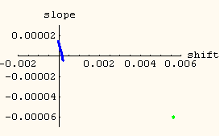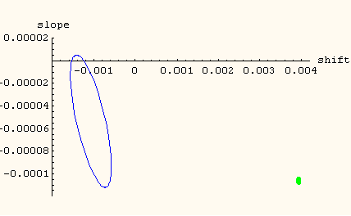

“Adjusted” errors: E_{M} = 0.0, E_{L} = 0.6 ppm = 0.0006 mm/m.

“Last correct point” distance = 0.5m “Last correct point” distances = 0.4m, 0.2m
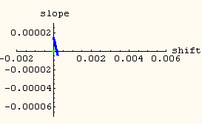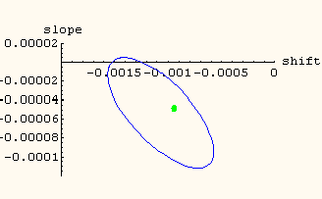

Conclusion
Within a few microns for the “pure” linear case the weighted fit and the geometric correction can be considered as equivalent. The adjustment of the uncertainties makes the results of the weighted fit closer to “real” GA z = 0. The correction procedure gives better result without adjustment of the uncertainties if the “last correct points” are known. Weighted fit is also much more complicated since any error in the estimate of the uncertainties leads to the incorrect result (see next section).

Comments on the Correctness of the Weighted Fit
Weighted fit with the original “big” errors and with neglected correlation of deflection shifts finds the GA very far from the Y axis and is not much better than the simple average (orange line on the plot below):

Bi = 0.499377

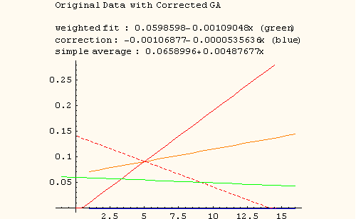

Trying to improve the Birge ratio we put E_{M} = 0.0, E_{L} = 5 ppm and we get “better” GA (see the figure on the next page)

z = 0.00465501 + 0.000153929 y,

and
Bi = 0.81

Same errors were used when checking the weighted fit with the end cover positions.

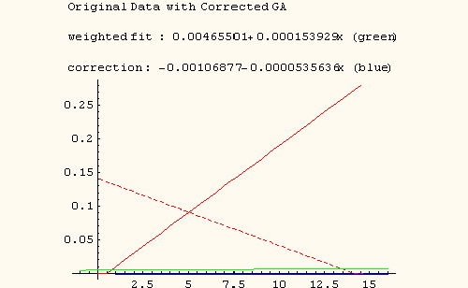

To “improve” the Birge ratio we put E_{L} = 0.6 ppm and thus get Bi = 0.94 and GA

z = 0.000141912 +0.0000113443 y

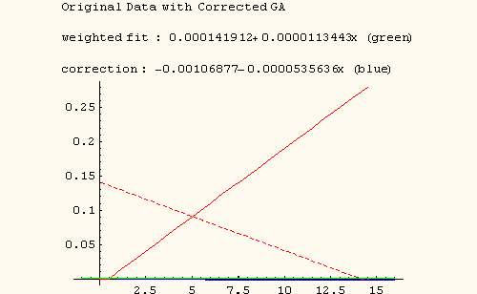

So, for the “pure” linear case the weighted fit can give the good results only when all input uncertainties are well estimated. The geometric correction gives an equivalent but more stable result.

